CHECK OUT SILICON VALLEY

Situated in the southern Bay Area, Silicon Valley is home to some of the largest technology companies in the world…and some of the smallest but most ambitious startups. Google, Apple and Facebook all have headquarters here and the atmosphere is electric.

(MARKET IMAGE HERE)

Find Deals From These Cities

INSERT FARE GRID FROM / TO Version (if available!)

   
Top Things To Do in Silicon Valley

When visiting Silicon Valley don’t miss these top attractions.

* Spend a day at The Tech Museum of Innovation, a nationally-awarded museum with the mission to inspire the innovator in everyone.
* Check out Google’s Visitor’s Map of the local highlights and headquarters.
* Explore downtown San Jose for a dose of live music, nightlife and shopping. Check out The Farmer’s Union restaurant for unique bites and 52 craft beers on tap.
* Stanford University is one of the world’s most prestigious institutions. Take a stroll around the beautiful campus and soak up the brilliance in the air.
* Need free WiFi? The Nikola Tesla Statue in Palo Alto is not only a stunning monument, but also a free WiFi access spot and a time capsule that will be opened in 2043.

Travel Tips and Resources

[Oakland Zoohttp://www.oaklandzoo.org/staging/Rides_Area.php](http://www.oaklandzoo.org/staging/Rides_Area.php)

[The Tech Museum of Innovationhttp://www.thetech.org/](http://www.thetech.org/)

<http://www.thetech.org/>

[Google Visitor’s Maphttps://www.google.com/maps/d/viewer?mid=zc_2vLrMI9XY.kOvBnM9xQmuA&hl=en_US](https://www.google.com/maps/d/viewer?mid=zc_2vLrMI9XY.kOvBnM9xQmuA&hl=en_US)

<https://www.google.com/maps/d/viewer?mid=zc_2vLrMI9XY.kOvBnM9xQmuA&hl=en_US>

[Japantown San Josehttp://www.jtown.org/](http://www.jtown.org/)

<http://www.jtown.org/>

[Stanford Universityhttps://www.stanford.edu/](https://www.stanford.edu/)

<https://www.stanford.edu/>

[Silicon Valley Restaurantshttp://www.metroactive.com/best-of-silicon-valley/2015/food-drink/reader-picks.html](http://www.metroactive.com/best-of-silicon-valley/2015/food-drink/reader-picks.html)

<http://www.metroactive.com/best-of-silicon-valley/2015/food-drink/reader-picks.html>

[San Jose Nightlifehttp://www.sanjose.com/nightlife/](http://www.sanjose.com/nightlife/)

<http://www.sanjose.com/nightlife/>

[Palo Alto Shoppinghttp://www.destinationpaloalto.com/pages/d/shopping?visitor_info_id=2](http://www.destinationpaloalto.com/pages/d/shopping?visitor_info_id=2)

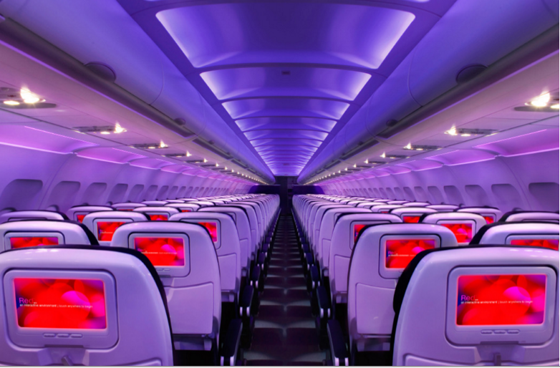

Main Cabin Main Cabin Select First Class

(add links to Cabin Class Pages)

Ready. Set. Fly.

Book your Mood-lit Ride to Silicon Valley.

Looking into flights to Silicon Valley, you’ll find the area is served by San Francisco International Airport. Travel in style and book your flight to Silicon Valley with Virgin America. Our leather seats were custom-designed to provide you with an unparalleled level of comfort. Our mood-lit cabins were thoughtfully crafted with your relaxation in mind. Our on-demand food ordering and on-demand WiFi and entertainment are offered to give you the ultimate in-flight conveniences. Fly Virgin America and arrive in Silicon Valley ready to work hard and play hard.

Take a Virtual Tour

Add Terms & Conditions